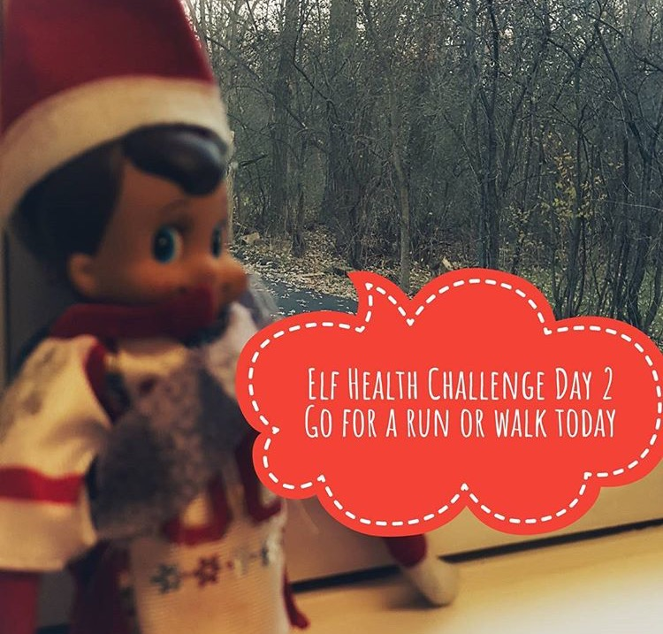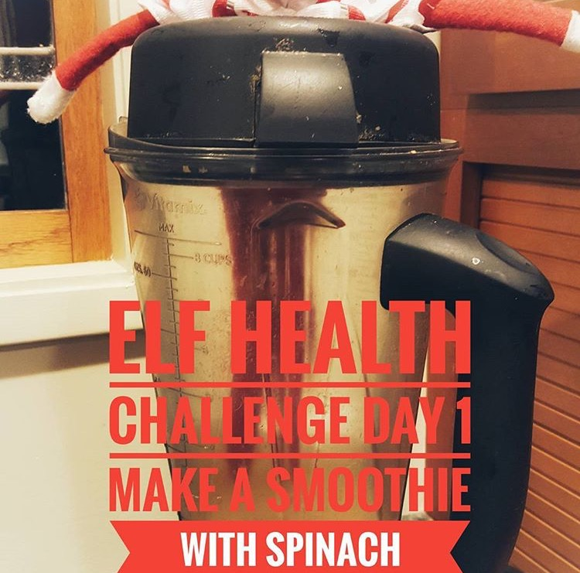

Elf Health Challenge: Day 2

Start your Elf Health Challenge right:

Day 1

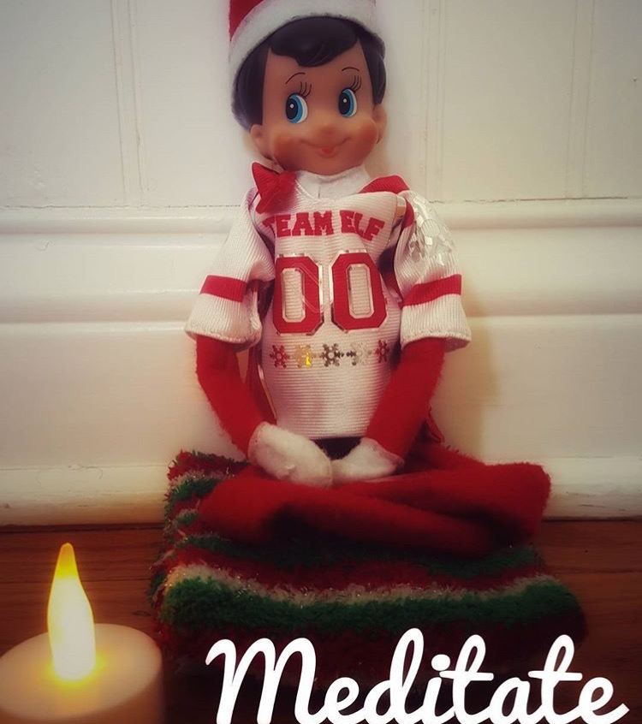

Elf Health Challenge Day 4:

Track your water intake. Take your weight and divide it in half. That is the amount of water in ounces you need to drink a day.

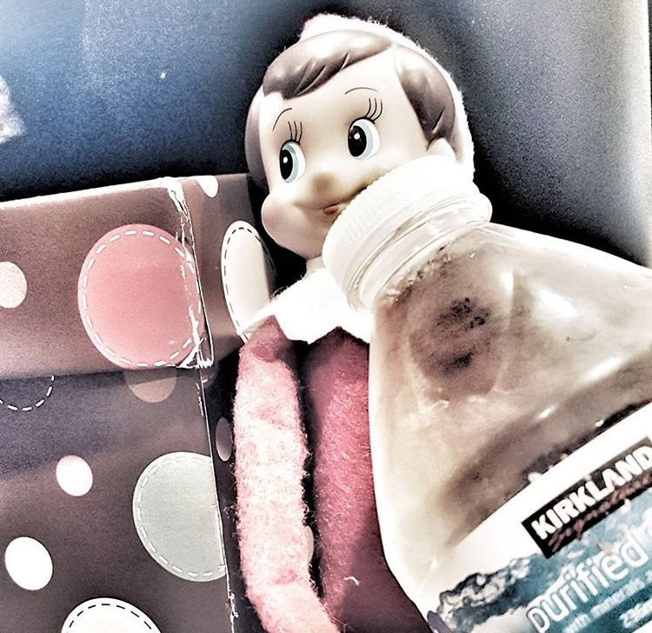

Elf Health Challenge Day 3:  
Meditate with the centering thought of Giving.

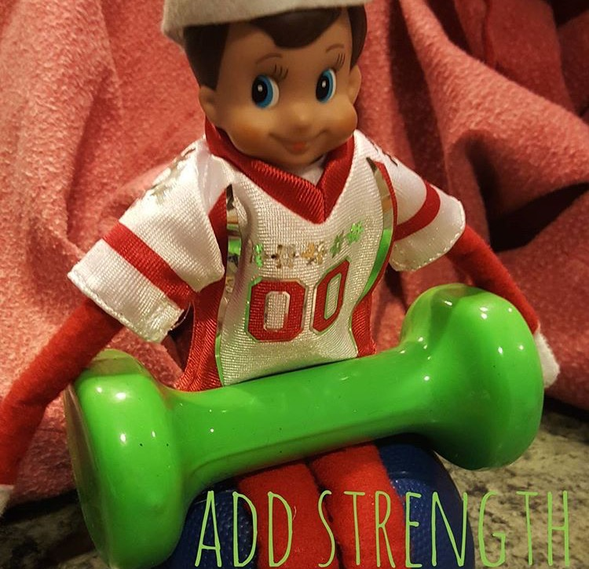

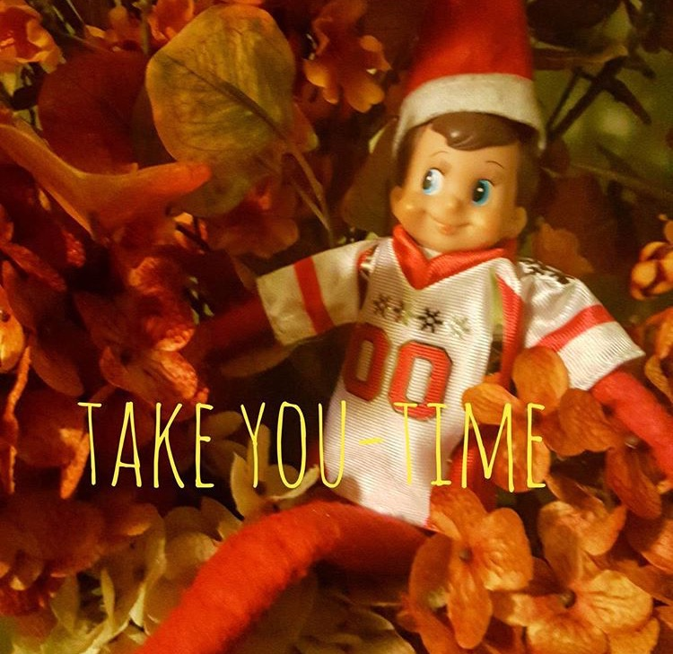

Elf Health Challenge Day 5:

Add strength training to your cardio workout. Easy strength exercises are push-ups, squats, and planks.

Elf Health Challenge Day 6:

Take some YOU time today. Relax and enjoy your moments.

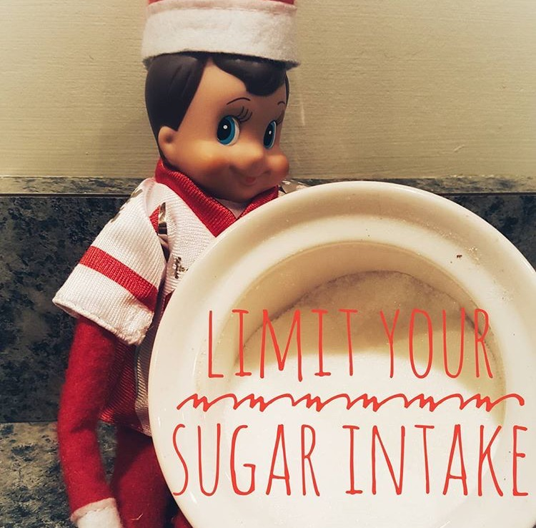

Elf Health Challenge Day 7:

Limit your Sugar intake to 6 to 9 tsp today. Watch out for Hidden sugars.



ELf Health Challenge Day 8:  
Add 50 sit ups to your workout today.



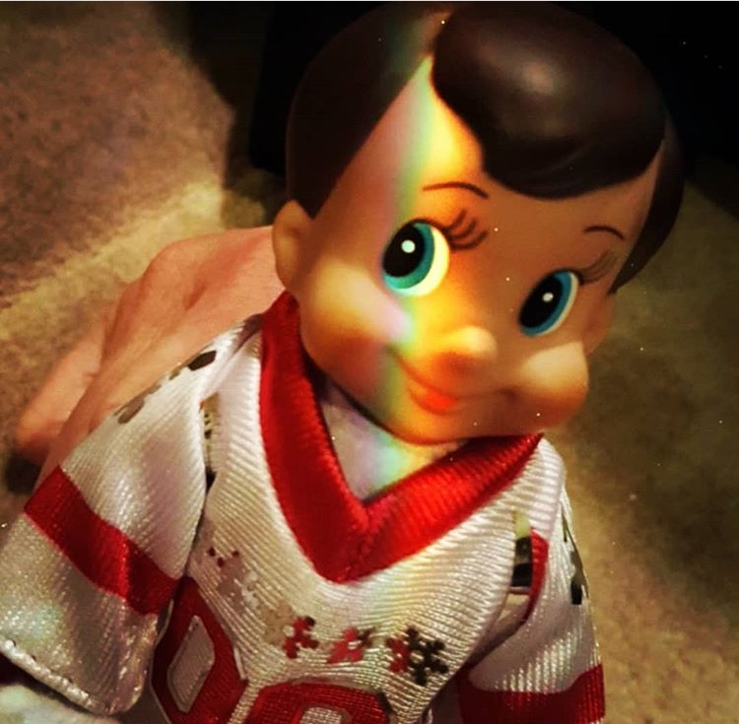

Elf Health Challenge Day 9:

Be Positive today!!! [#elbconsulting](https://www.facebook.com/hashtag/elbconsulting?source=feed_text&story_id=810269095764493)

Elf Health Challenge Day 10:

Eat the rainbow of fruits and vegetables a day.



Elf Health Challenge Day 11: Add pull ups to your workout even if it is just one. Amazing total body exercise.

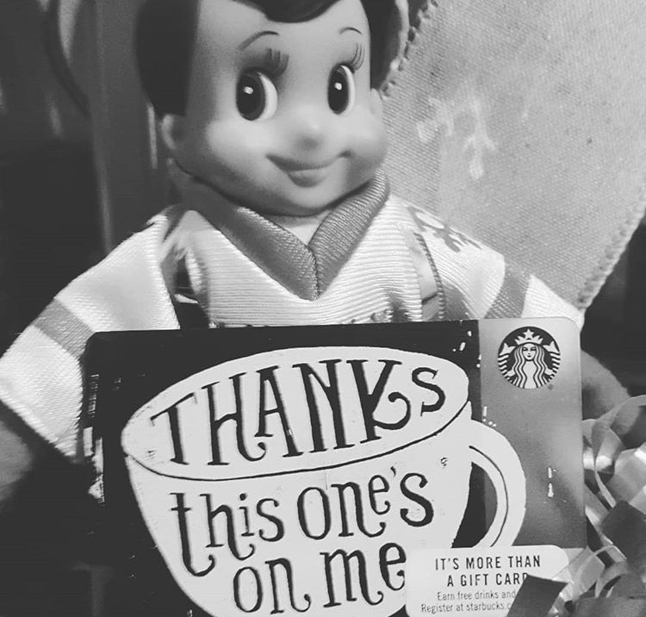

Elf Health Challenge Day 12:

Pay It Forward!!

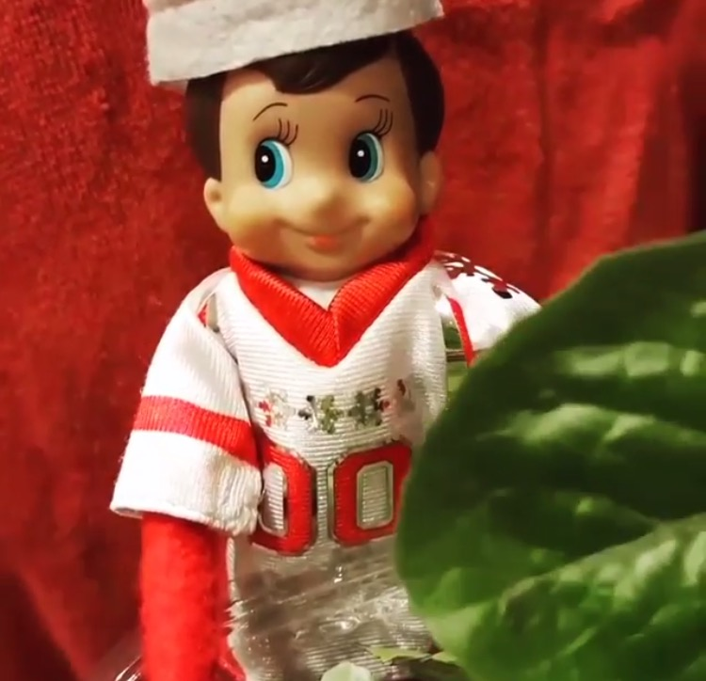

Elf Health Challenge Day 13:

Add greens to your day. 1/2 cup of broccoli or 1 cup of lettuce is all you need.

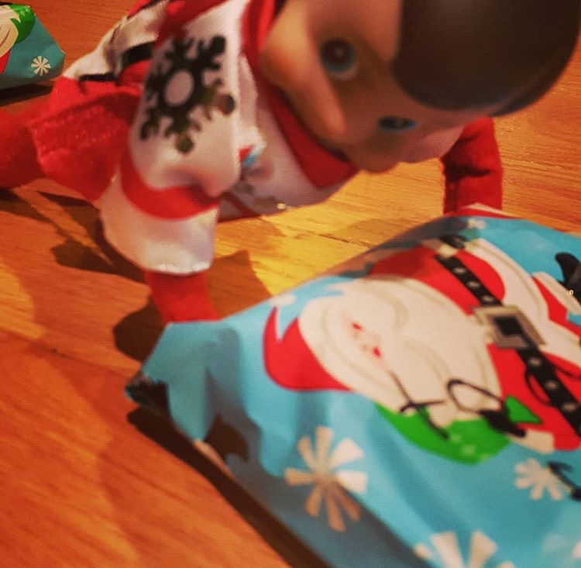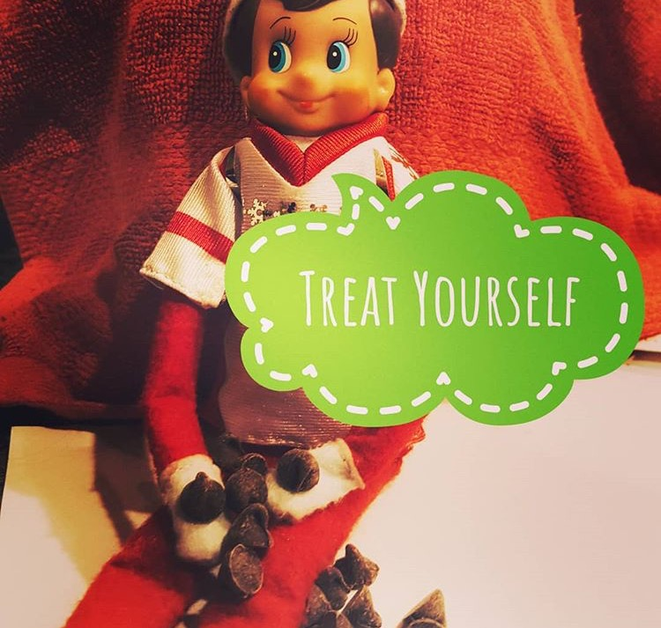

ELf Health Challenge Day 15:

Treat yourself with some sweets. Gotta love chocolate https://static.xx.fbcdn.net/images/emoji.php/v9/feb/2/16/1f642.png

Elf Health Challenge Day 14:

Hold a plank for 1 minute.

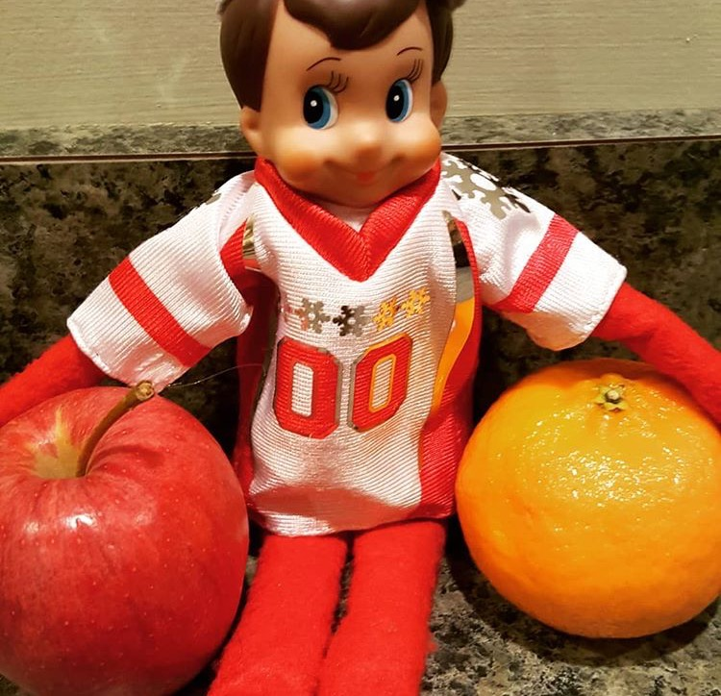



Elf Health Challenge Day 17:

Add burpees to your workout today.

Elf Health Challenge Day 16:

Add fruits to your day. At least 5 servings https://static.xx.fbcdn.net/images/emoji.php/v9/feb/2/16/1f642.png



Elf Health Challenge Day 18:

Enjoy a nice long hot bath with essential oils.

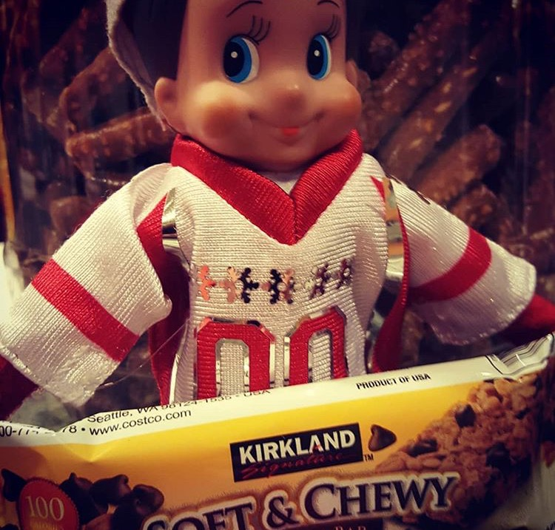

Elf Health Challenge Day 19. Reduce your starchy white refined carbohydrates today. Fill up on Fruits and vegetables instead.

Elf Health Challenge Day 20:

Add overhead squats to your workout for an awesome leg day and to increase calorie expenditure.

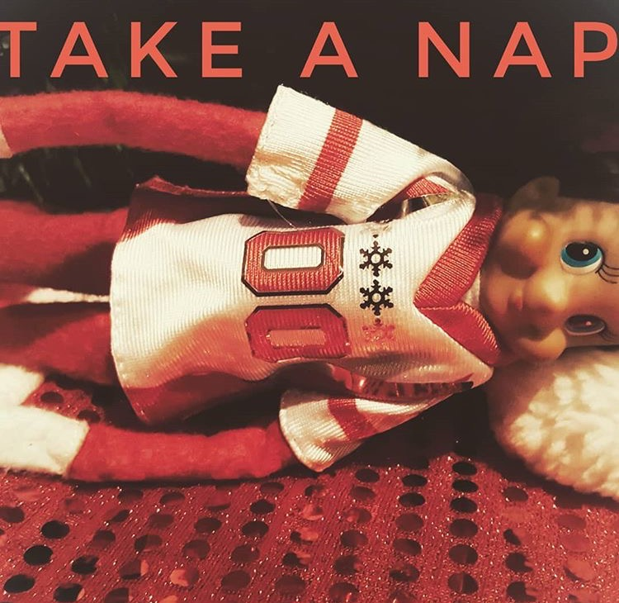

Elf Health Challenge Day 21:

Take a 20 min nap to recharge the body during the holiday season.

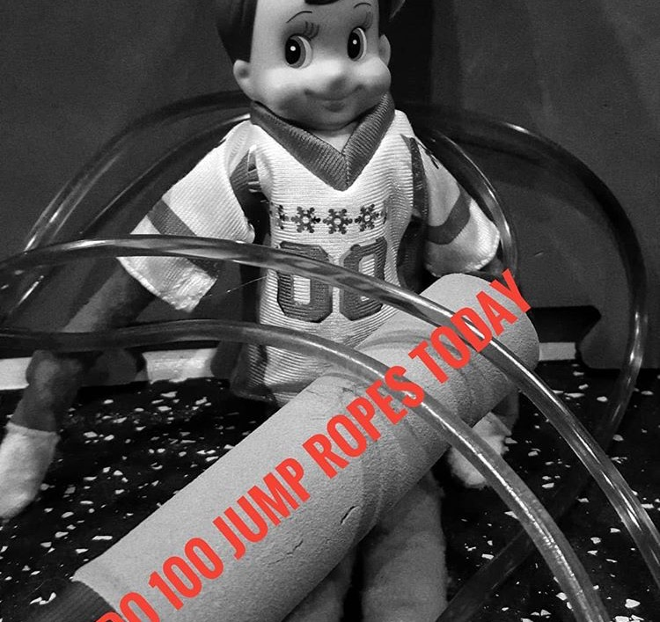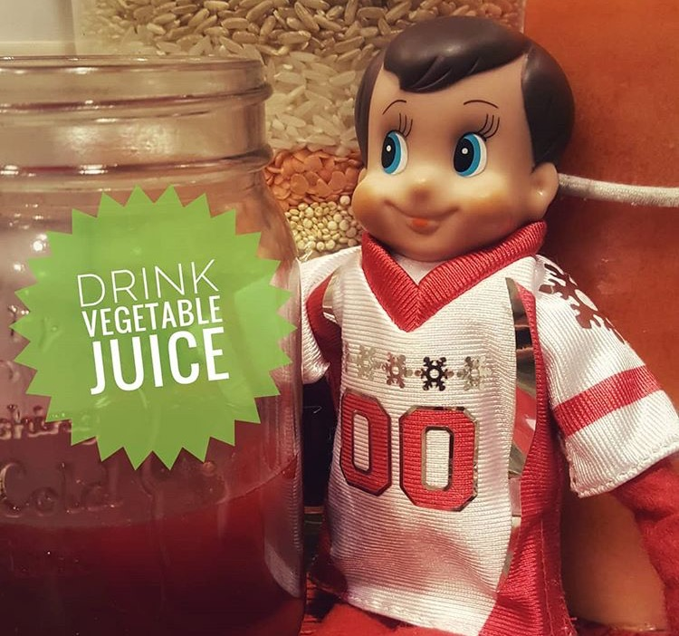

Elf Health Challenge Day 23:

Add 100 jump ropes today.

Elf Health Challenge Day 22:

Drink a vegetable juice to nourish the body. Wheat grass, Beet Juice, and Green Machine are great choices.

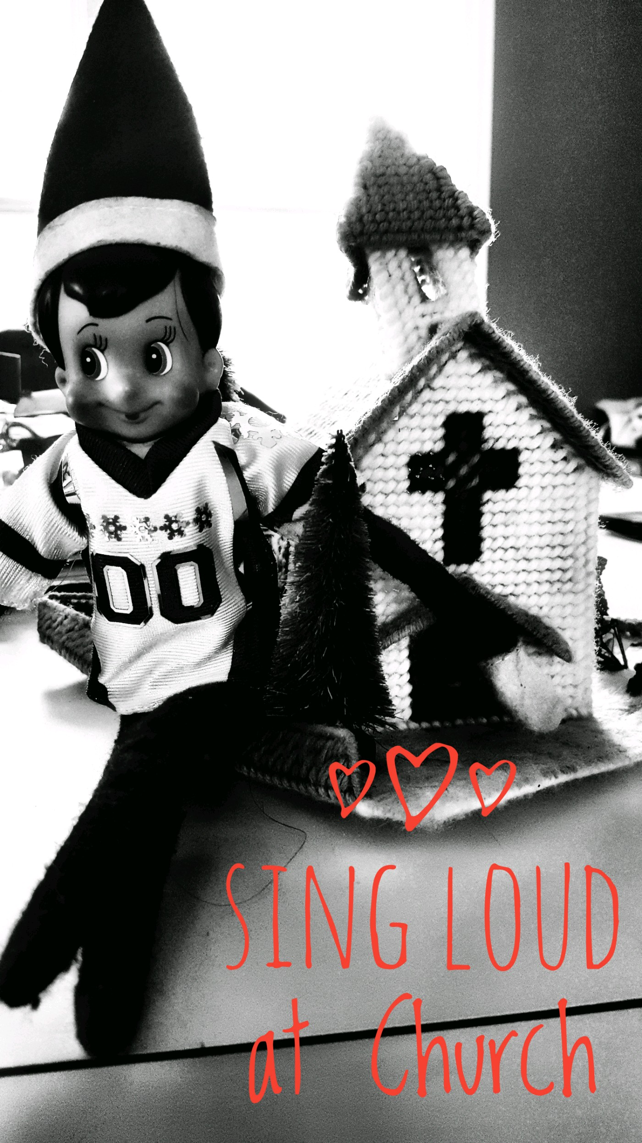

Elf Health Challenge Day 24:

Enjoy Church and Sing!!

-

Elf Health Challenge Day 25:

Relax and be with the family!!

☺